FOR IMMEDIATE RELEASE
Contact: Danni Wang, 213-210-2500 x22
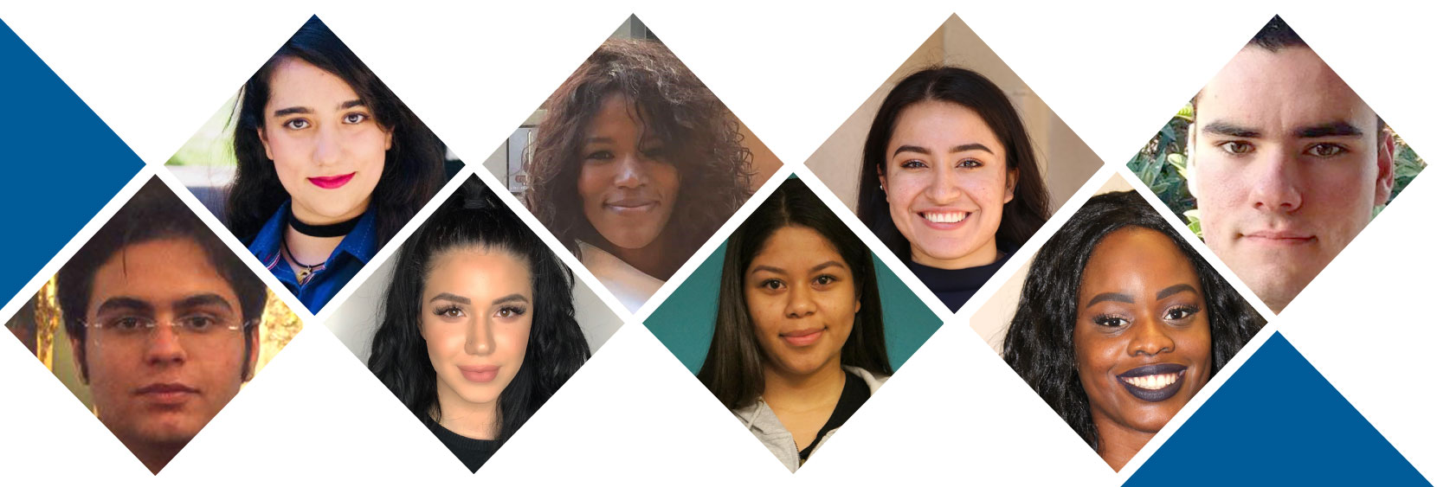

Twelve LACCD Students Announced as Semifinalists
for Prestigious Cooke Foundation Scholarship

LOS ANGELES, CA — The Los Angeles Community College District (LACCD) announced that 12 students across six of its colleges have been named semifinalists for the Jack Kent Cooke Foundation Undergraduate Transfer Scholarship, worth up to $40,000 per year and renewable for up to three years.

The scholarship benefits outstanding community college students with financial need by supporting their matriculation to four-year colleges. The highly selective program receives nearly 2,500 applications each year from community colleges across the country. Only around 45 scholarships are awarded annually.

“One of the biggest challenges a student faces is the cost of attending college,” said Sydney Kamlager-Dove, President of LACCD’s Board of Trustees. “Scholarships are opportunities for greater pathways. Until we figure out how to make college free, we will continue to partner with funders to help make our students' educational dreams a reality. We salute these 12 stellar students and the faculty, staff and family members who have supported them on their journey.”

“Many of our students come from working-class backgrounds and struggle with financial hardships, but they are resilient and consistently demonstrate tremendous resolve to succeed,” said Trustee Steve Veres, Chair of LACCD’s Institutional Effectiveness and Student Success Committee. “Our colleges are committed to elevating every student for future success, whether they choose to enter the workforce, transfer to a 4-year college, or take advantage of life-changing opportunities like the Cooke Scholarship.”

The Cooke Foundation named 534 scholarship semifinalists for 2018. The Undergraduate Transfer Scholarships will fund various college costs that are not covered by financial aid, including study abroad fees and internship stipends. In addition, Cooke Scholars will receive academic advising and join a vast network of outstanding students and scholarship alumni. Following their undergraduate studies, Cooke Scholars are also eligible to apply for graduate school scholarships worth up to $75,000.

“The real costs of attending college deter many promising students from completing their educational goals,” said LACCD Chancellor Francisco Rodriguez, Ph.D. “The Cooke Foundation’s generous scholarship program ensures that many of these students will have the support they need to overcome financial barriers and achieve their full potential.”

The Cooke Foundation will select finalists for the Undergraduate Transfer Scholars program in April based on each applicant’s academic performance, leadership, perseverance, and service to others.

The LACCD students recognized as semifinalists are:

Georgine Akpuh – LA Valley College
Kevin Bernal-Rivera – LA Trade Tech
Tahmineh Dehbozorgi – LA Pierce College
Hannah Gehrels – LA City College
Matin Ghavamizadeh – LA Valley College
Nefry Godoy – West LA College
Daniel Gomez – East LA College
Jasmine Hernandez – LA Valley College
Lily Keshishian – LA Pierce College
Tara Makabi – LA Pierce College
Adriana Perez-Munuzuri – East LA College
Jonathan Portillo – LA Valley College

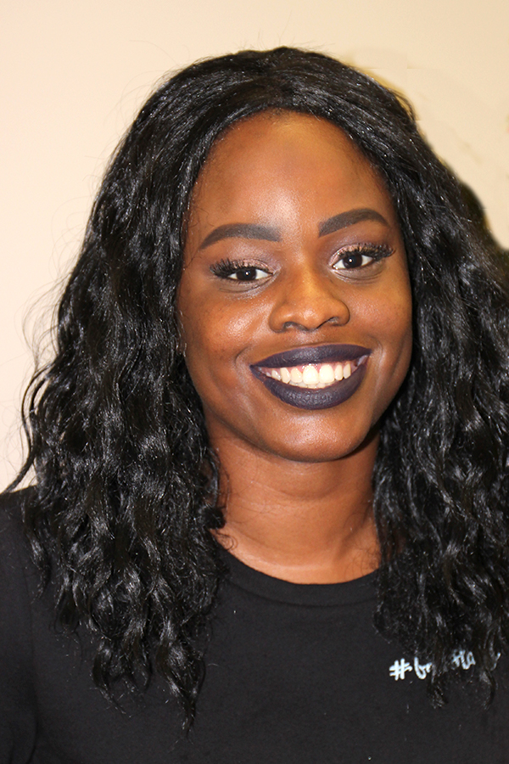 | 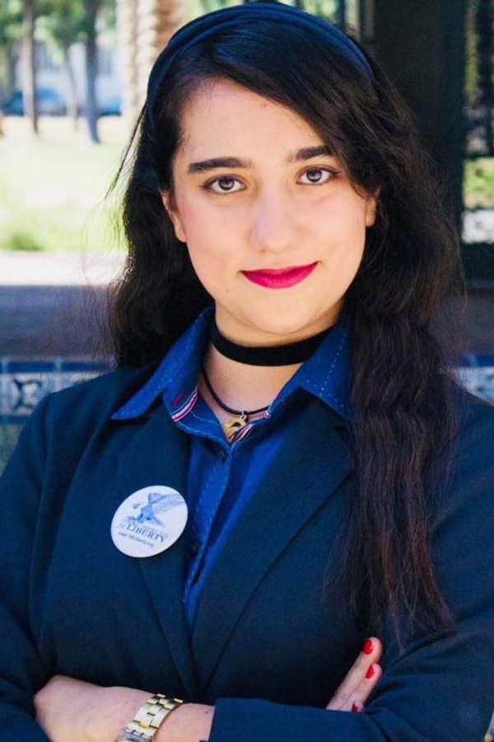 | 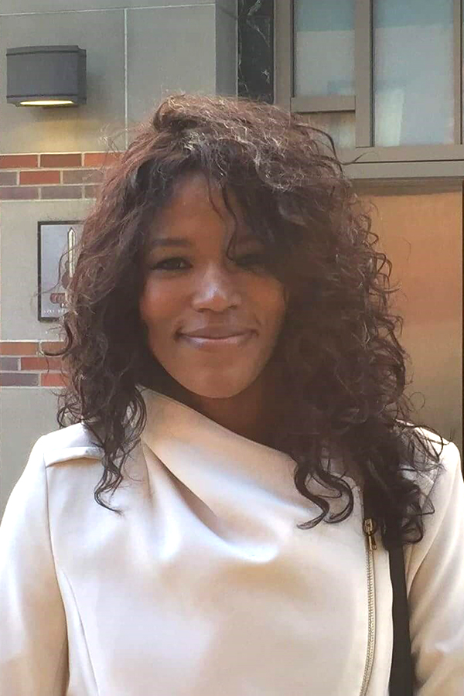 | 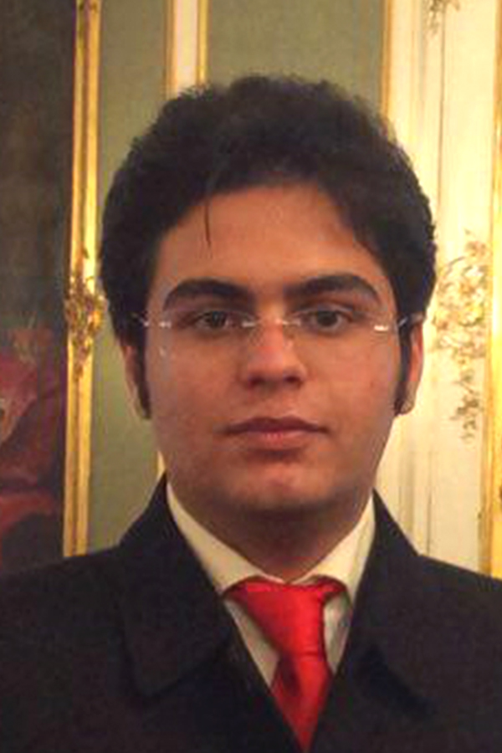
Georgine Akpuh  LA Valley College | Tahmineh Dehbozorgi  LA Pierce College | Hannah Gehrels  LA City College | Matin Ghavamizadeh  LA Valley College
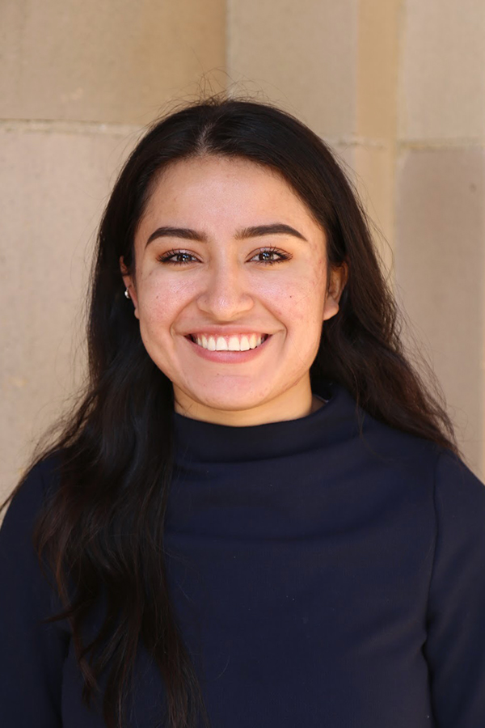 |  | 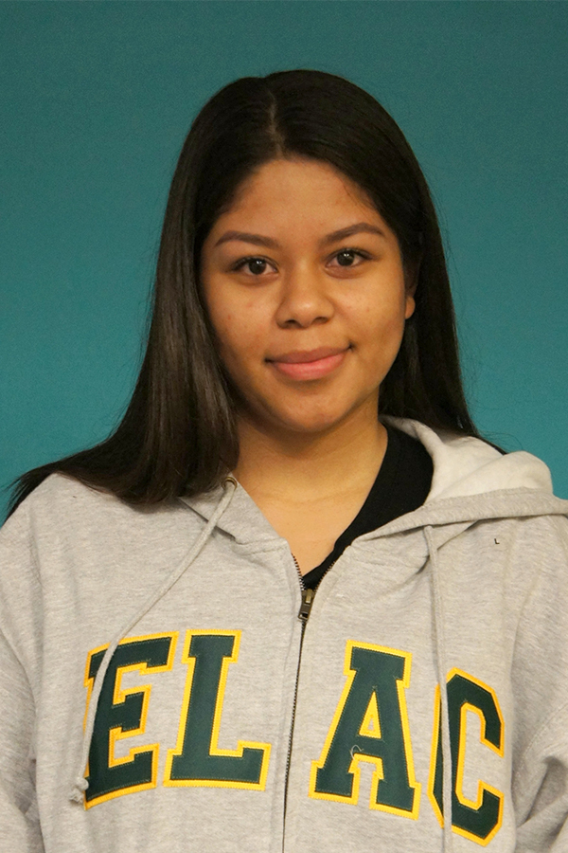 | 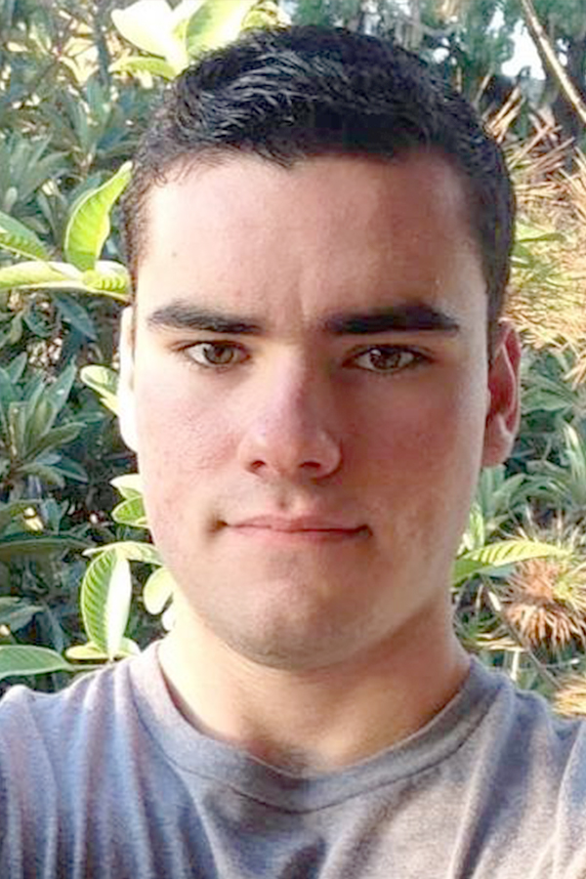
Jasmine Hernandez LA Valley College | Lily Keshishian  LA Pierce College | Adriana Perez-Munuzuri  East LA College | Jonathan Portillo  LA Valley College
###

About the Los Angeles Community College District
The Los Angeles Community College District, the nation’s largest community college district, serves one-quarter million students a year in more than 36 cities in Los Angeles County at its nine colleges. The District covers nearly 900 square miles and has educated and trained the region’s diverse workforce since 1969.

Members of the Board
Sydney Kamlager-Dove, President | Mike Fong, Vice President | Gabriel Buelna, Ph.D. | Andra Hoffman | Ernest H. Moreno | Scott J. Svonkin | Steven F. Veres | Christopher Martinez, Student Trustee

