- 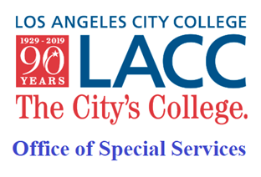  - Happy Fall!  2022  The Office of Special Services (OSS) is available in-person and online (hybrid).  In this issue, we will cover the following topics:  - OSS Reminders & Supports, p.1-2  - Learning Foundation class, p. 2  - OSS Faculty Update, p. 2  - Campus reminders and updates, p.3  - Contact Us  Los Angeles City College  855 N. Vermont Avenue  Los Angeles, CA 90029  Office of Special Services  Student Services Bldg., 1st fl.  Phone: (323) 953-4000 ext. 2270 (TTY/TDD)  Email: oss@lacitycollege.edu  Cranium Café:  https://tinyurl.com/w7zhpu75  Website: https://tinyurl.com/2xfekjbx | OSS Student Newsletter  Volume 2, Issue 1  Hello OSS Students! Below you’ll find information and reminders to make sure your Fall 2022 semester gets off to a successful start!  HAVE YOU UPDATED YOUR OSS APPLICATION FOR FALL 2022?  If not, complete it here at: https://tinyurl.com/s7ubb76p  Then email completed form to: oss@lacitycollege.edu  OSS COUNSELING AND DISABILITY SPECIALIST  Have you contacted your Counselor or Disability Specialist to request your accommodations for Fall? Please make sure to include your student ID number whenever you email or leave a voice message to your counselor or specialist. Remember: you must reach out to your counselor or specialist at the beginning of each semester to ask for your accommodation letters.  Counselors and Disability Specialists will be available both online and in-person, Mondays-Fridays (specific days per counselor/specialist will vary). When emailing, please be sure to include your student ID number!  - Student last names, A – L, email Robert Dominick: DominiRT@laccd.edu  - Student last names, M – Z, email Houa Lee: LeeH7@laccd.edu  - Students with learning disabilities, email Donna Morley: MorleyDA@laccd.edu  - Accessibility, alternative media and assistive technology, email Ryan Kushner: kushnera@lacitycollege.edu  ORDERED YOUR ALTERNATE MEDIA?  Email the High Tech Center (HTC) to get the proper forms: OSSHTC@lacitycollege.edu  Then email completed forms to Kelvin Luong: luongk@lacitycollege.edu  OSS TUTORING  We are offering Math and English tutoring, and also working with the Writer’s Block to provide specialized writing tutoring to our students.  Contact osstutor@lacitycollege.edu for more information. To receive tutoring, you must be enrolled in classes at LACC and add our non-credit, non-graded Tutor I section 10686.  ALTERNATIVE TESTING  Alternative Testing will continue to be available both online and/or in-person for on-campus classes only. Please remember to email alternative testing at least 3 days before your exam. ossexams@lacitycollege.edu  READY TO IMPROVE YOUR KEYBOARDING SKILLS?  Fast, efficient keyboarding can have a huge impact on student success. Sign up for Learning Foundations 1 class. This one-unit pass/no pass class is available completely online and uses a fun, effective new program. Work at your own pace – you set the schedule. We will also have in-person lab hours available if you prefer in-person support.  - Learning Foundations 1 (section 19192) Adapted Keyboarding – will increase your keyboarding speed and accuracy.  Still need tech help? Reach out to osshtc@lacitycollege.edu for assistance.  MEET OUR NEWEST OSS FACULTY MEMBER!  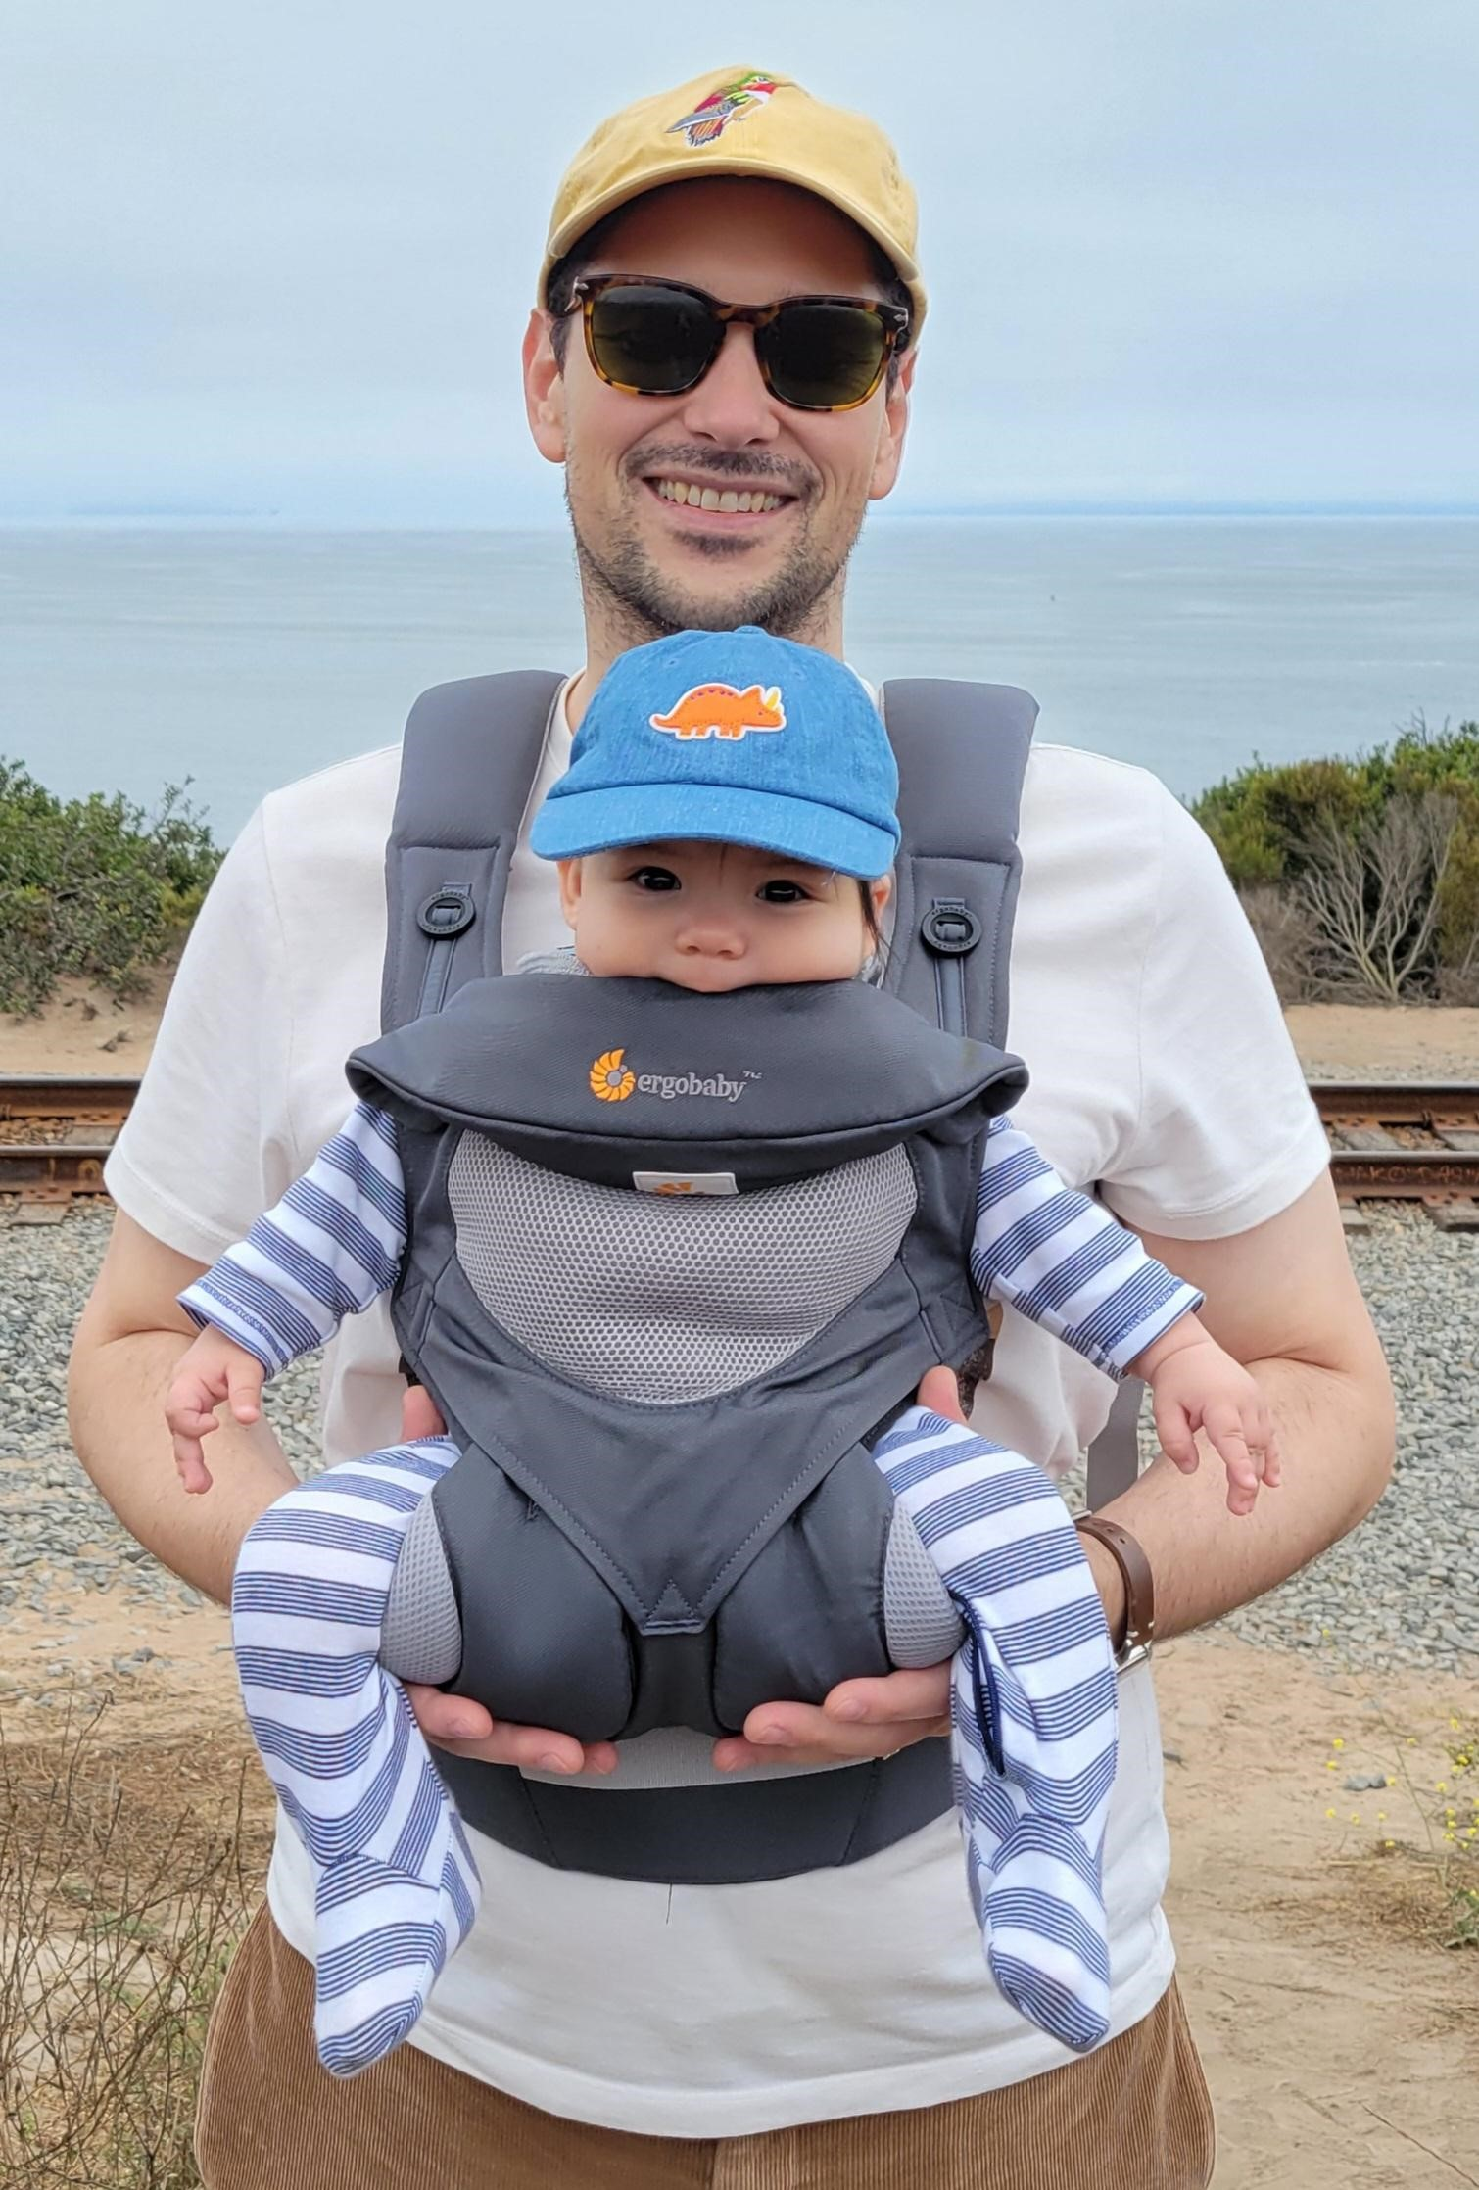  Ryan Kushner began his career in OSS back in 2010 as a student volunteer and has stayed with OSS, serving in a number of different roles, ever since. He graduated from UCLA with a degree in Applied Mathematics and completed a master's degree in Assistive Technology and Human Services at CSUN. He has been an Instructor, Special Assignment since Fall 2015 tasked with working on campus accessibility as well as teaching assistive technology.  BEAT THE RUSH AND WELCOME WEEK  Beat the Rush Week begins Monday August 15 and lasts through August 27. Select student services areas will have extended hours both in-person and online, Mondays through Thursdays, 8am to 7pm & Fridays 8am to 4:30pm. Special Saturday Hours on August 27, from 9am to 1pm.  These areas are Admissions & Records, Bookstore, General Counseling, Business Office, EOP&S, Financial Aid, Non-Credit/Adult Education, and the Welcome Center.  Welcome Week begins Monday, August 29th and lasts through Saturday, September 3rd. Select student services areas will have extended hours both in-person and online, Mon-Thur 8:00 am to 7:00 pm; Friday, 8:00 am to 4:30 pm. Special Saturday hours on September 3rd, 9 am – 1pm. Areas include Financial Aid, Business Office, Admissions and Records, and more.  STUDENT PARKING – FALL 2022  Student parking remains free for all students.  UPDATES ON MASKS  Currently, status of no indoor masking remains (but still recommended). Please be sure to still complete the Cleared4 questions before coming onto campus.  FUN LESSONS! (FEATURING DEAF/HARD-OF-HEARING)  How to say “school” in American Sign Language!  