- 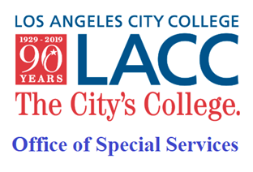  - Happy Spring!  2023  The Office of Special Services (OSS) is available in-person and online (hybrid).  In this issue, we will cover the following topics:  - OSS Reminders & Supports, p.1-2  - Learning Foundation class, p. 2  - Online Job Fair, p. 2  - Kinesiology class, p. 2-3  - Foundation Office Scholarships, p. 3  - Contact Us  Los Angeles City College  855 N. Vermont Avenue  Los Angeles, CA 90029  Office of Special Services  Student Services Bldg., 1st fl.  Phone: (323) 953-4000 ext. 2270 (TTY/TDD)  Email: oss@lacitycollege.edu  Cranium Café:  https://tinyurl.com/w7zhpu75  Website: https://lacitycollege.edu/student-services/spr/oss | OSS Student Newsletter  Hello OSS Students! Below you’ll find information and reminders to make sure your Spring 2023 semester gets off to a successful start!  HAVE YOU UPDATED YOUR OSS APPLICATION FOR Spring 2023?  If not, complete it here at: https://www.lacitycollege.edu/sites/lacc.edu/files/2022-08/OSS-CONTINUING_STUDENT_FORM_Rev_2021.pdf  Then email completed form to: oss@lacitycollege.edu  OSS COUNSELING AND DISABILITY SPECIALIST  Have you contacted your Counselor or Disability Specialist to request your accommodations for Spring? Please make sure to include your student ID number whenever you email or leave a voice message to your counselor or specialist. Remember: you must reach out to your counselor or specialist at the beginning of each semester to ask for your accommodation letters.  Counselors and Disability Specialists will be available both online and in-person, Mondays-Fridays (specific days per counselor/specialist will vary). When emailing, please be sure to include your student ID number!  - Student last names, A – L, email Robert Dominick: DominiRT@laccd.edu  - Student last names, M – Z, email Houa Lee: LeeH7@laccd.edu  - Students with learning disabilities, email Donna Morley: MorleyDA@laccd.edu  - Accessibility, alternative media and assistive technology, email Ryan Kushner: kushnera@lacitycollege.edu  ORDERED YOUR ALTERNATE MEDIA?  Email the High Tech Center (HTC) to get the proper forms: OSSHTC@lacitycollege.edu  Then email completed forms to Kelvin Luong: luongk@lacitycollege.edu  OSS TUTORING  We are offering Math and English tutoring, and also working with the Writer’s Block to provide specialized writing tutoring to our students.  Contact osstutor@lacitycollege.edu for more information. To receive tutoring, you must be enrolled in classes at LACC and add our non-credit, non-graded Tutor I section 15425.  ALTERNATIVE TESTING  Alternative Testing will continue to be available both online and/or in-person for on-campus classes only. Please remember to email alternative testing at least 3 days before your exam. ossexams@lacitycollege.edu  READY TO IMPROVE YOUR KEYBOARDING SKILLS?  Fast, efficient keyboarding can have a huge impact on student success. Sign up for Learning Foundations 1 class. This one-unit pass/no pass class is available completely online and uses a fun, effective new program. Work at your own pace – you set the schedule. We will also have in-person lab hours available if you prefer in-person support.  - Learning Foundations 1 (section 19470) Adapted Keyboarding – will increase your keyboarding speed and accuracy.  Still need tech help? Reach out to osshtc@lacitycollege.edu for assistance.  CHECK OUT THE ABILITY JOB FAIR  February 9, 2023 online job fair: https://tinyurl.com/49hw8nk4  KINESIOLOGY 45 – 1 UNIT  Looking for a fun class to get fit and satisfy your kinesiology requirement? There are still spots available in:  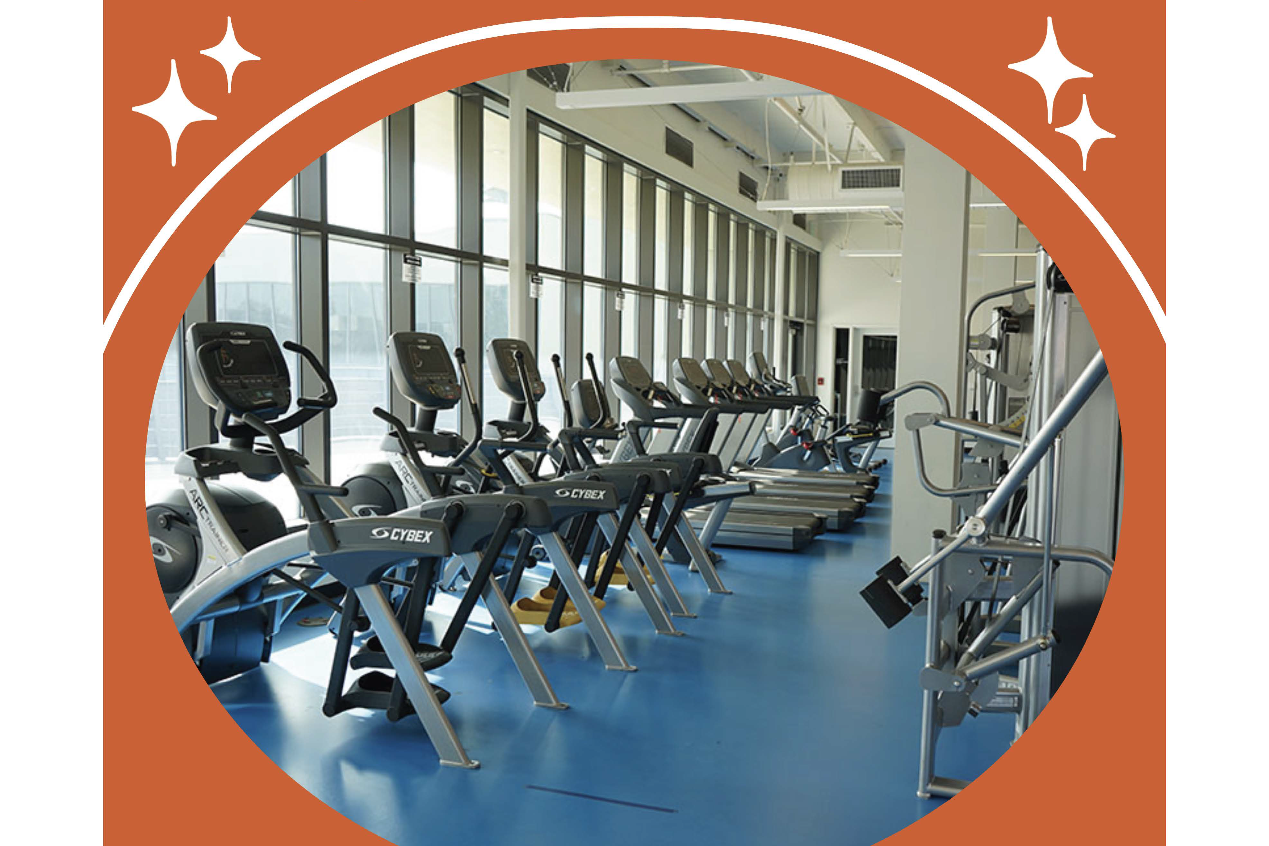  KIN 045 Adapted Fitness, Spring 2023  Thursdays 9:35-11:40 Section 25355  This PE course is designed to meet the needs of students with a verified disability who require restricted or modified activities. Safe and effective individualized exercise programs are performed by students such as cardio machines, barbells, kettle balls, weight machines, dumbbells and more.  FOUNDATION SCHOLARSHIP AND RESOURCES  The Foundation Office is offering scholarships, textbook vouchers, and laptop awards for Spring 2023. Students must create an LACC Foundation Account to access the online applications. Late applications will not be accepted.  See scholarship details and links below.  GET REWARDED FOR YOUR HARD WORK!  Invest time now and apply for Spring 2023 Scholarships! Save money and focus on your studies! Awards range from $250 to $1k! Deadline is February 28th! https://tinyurl.com/zcx43cy9  DON’T BREAK THE BANK ON COLLEGE TEXTBOOKS!  Get the resources you need to succeed and apply for LACC Foundation’s Book Voucher! (First come, first served opportunity!) Deadline is February 24th! https://tinyurl.com/yc7vdvy2  WE’RE LIVING IN A DIGITAL WORLD, WE KNOW YOU NEED THAT LAPTOP  Apply for the LACC Foundation Spring 2023 Laptop Award to receive a HP 255 G8 Laptop! (First come, first served opportunity!) Deadline is February 24th! https://tinyurl.com/4y9bpf2z  Zoom drop-in sessions are also available on the following Fridays:  - Feb 3, 2023 12:00 PM  - Feb 10, 2023 12:00 PM  - Feb 24, 2023 12:00 PM  - Feb 27, 2023 12:00 PM  Sign up for the Zoom drop-in session here: https://tinyurl.com/5byka3nx  Questions? Contact the LACC Foundation at (323) 953-4011, or info@laccfoundation.org

