How to Access Accommodation Letters

If you are teaching a course and receive a student accommodation letter from the Office of Special Services (OSS)/your local Disability Services Office (DSPS), here is a quick guide on how to access the accommodation letter from your rosters and emails.

Example:

When you open your roster, you should see a column on the far right that reads “Accommodation.” If a student has an accommodation for your class, you will see a hyperlink identified as “Accommodation.” You will need to click on the hyperlink to access the accommodation letter.
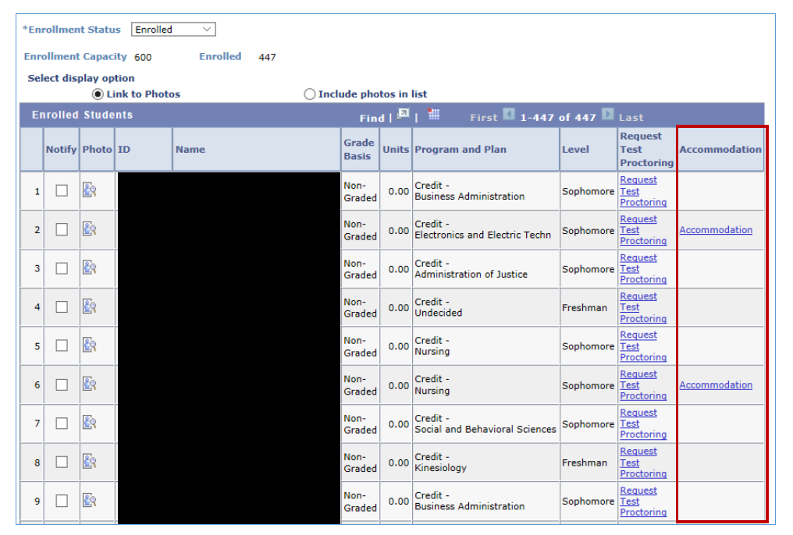

Once you click on the “Accommodation” hyperlink you will see the accommodation letter. Section B (pictured below) requires your response:

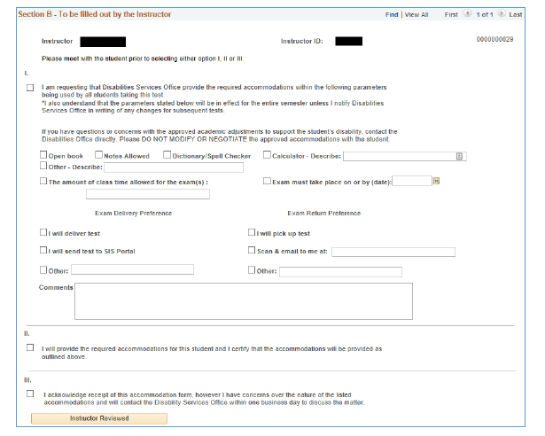

To acknowledge the accommodation letter, you can choose one of the three listed responses: Item I, II or III. If you do not have any questions regarding the accommodation, choose “I or II.” If you have questions or concerns, please choose “III” and contact OSS at oss@lacitycollege.edu or your local Disability Services Office (DSPS) for clarifications.

**It is crucial that you acknowledge the accommodation letter by choosing an option as listed so that the accommodation is implemented for the student and recorded in PeopleSoft.

Please do not ignore or bypass the accommodation letter. You must acknowledge the accommodations by choosing one of the identified options.

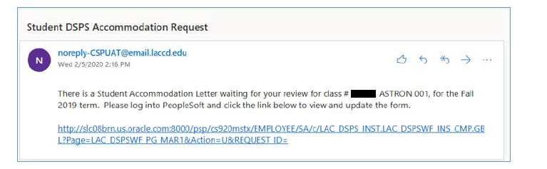

You may also receive an email notification stating that you have an accommodation letter in your roster waiting for your acknowledgement. This email will come from the noreply-CSPUAT@email.laccd.edu email address. You must be signed into your SIS account (Peoplesoft) in order to access the accommodation letter. If you click the link in your email and are not signed into your SIS account, you cannot access the accommodation letter (make sure you are signed into your SIS account).

If you are signed into your SIS account, click on the accommodation link notification, you will receive accommodation letter notifications in your browser. Note: If your browser is blocking pop-ups, you will need to reset your browser to allow pop-ups. Please see the diagram below:

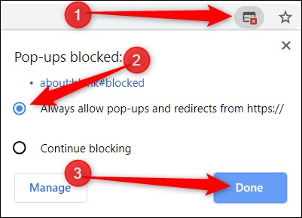

If you see an icon on the right side of your browser’s address window like the one identified in item 1 above, your browser is blocking pop-ups. Click on the icon and choose “Always allow pop-ups.” Then press “done.” This will allow you to open future accommodation letters once pop-ups are unblocked.

Legal Mandates:

Under Title II of the federal Americans with Disabilities Act (ADA), no qualified individual with a disability shall, by reason of such disability, be excluded from participation in or be denied the benefits of the services, programs, or activities of a public entity, or be subjected to discrimination by any such entity. (42 U.S.C. § 12132.) A public entity shall furnish appropriate auxiliary aids and services where necessary to afford individuals with disabilities an equal opportunity to participate in, and enjoy the benefits of, a service, program, or activity of a public entity. (28 C.F.R. § 35.160(b).)

An accommodation letter, which is the result of the interactive process between your local DSPS office and the student, identifies the academic adjustments, auxiliary aids, services and/or instruction necessary to provide the student equal access to the educational process, given the educational limitations resulting from the student’s disabilities. (See 5 C.C.R. § 56022.)

Your acknowledgment of accommodation letters will help ensure students in your course have an equal opportunity to benefit.

Accessible Course Materials:

As a reminder, faculty have an obligation to make course materials accessible to individuals with disabilities. OSS/your local Disability Services Office (DSPS) approves accommodations based on each student’s disabilities. Course materials should be accessible to promote diversity, inclusivity, and equality. If you need help, please contact your department chair or the dean for your area if you have concerns or questions about accessible course materials.

